UD Sub Box- Parts List

1 UD Sub Box
1 Flex Bracket
1 Wire Tie
2 7/16” Nuts
2 Lock Washers
2 Washers
2 Screws
1 Installation Guide
1 6.5” Subwoofer (optional)

We highly recommend a professional install the UD Sub Box. For any questions or comments call us at (727) 843-8424 from 9:00 A.M. to 6:00 P.M. (Eastern Standard Time) Monday thru Friday.

Please read the entire Install Guide before installing the UD Sub Box in your Spyder. Estimated Install Time should safely be 2-3 hours.

List of Recommended Tools

Deep 10mm Socket and Socket wrench
7/16” Socket or open-end wrench.
Snap On 10mm Gear Wrench or 10mm Open End Wrench
Panel Removal Tool
#2 Phillips Screw Driver
Wire Strippers
6.0” to 8.0” Extension for socket wrench
Wire from your sub to your amp
Right angle air grinder with sanding disc

INSTALLATION GUIDE
UNDERDASH SUB ENCLOSURE FOR MR2 SPYDER
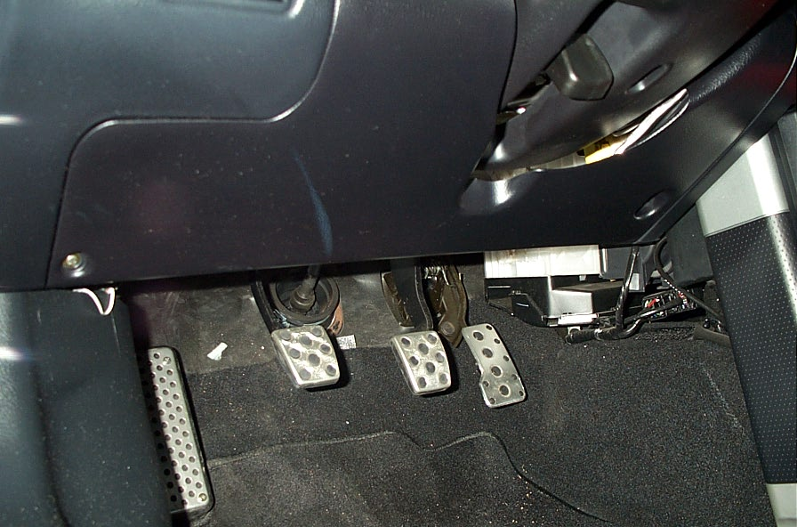
- Disconnect the vehicle’s battery.
2. Locate the knee panel on the driver’s side. The knee panel will have a 10mm bolt and a Phillips screw near the bottom of panel. Your Diagnostic Plug is located on the bottom left of this panel.
  - Remove both the 10mm bolt and the Phillips screw.
  - Remove the diagnostic plug from the knee panel. Two tabs snap the diagnostic plug in.
  - Remove the knee panel from car.
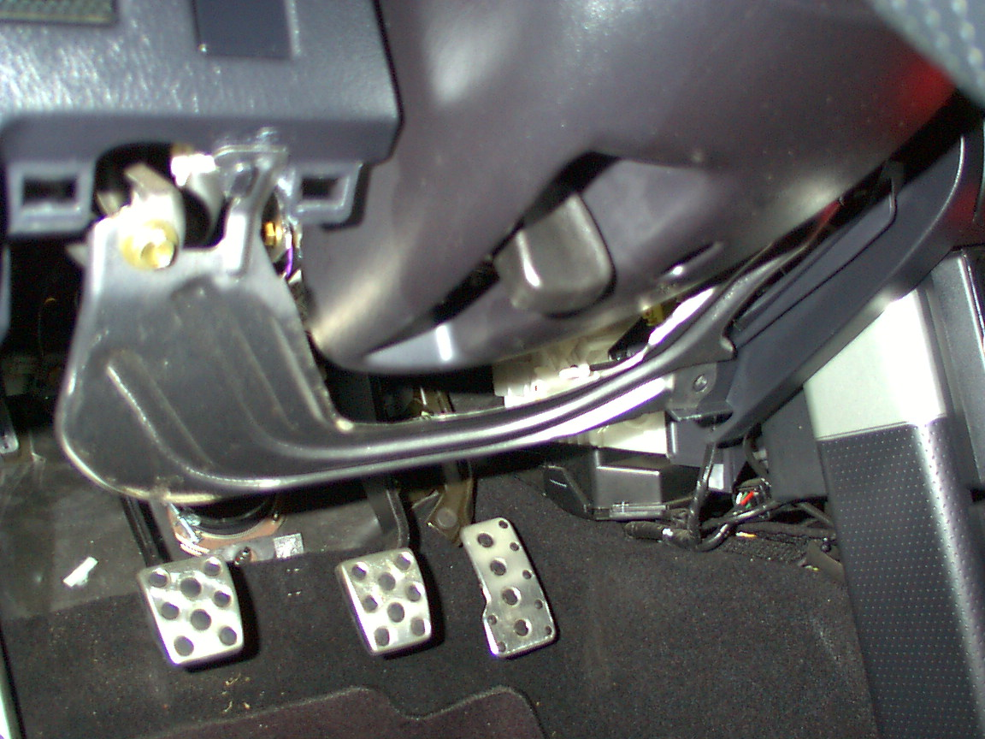
- Locate the metal framing under the knee panel.
  - Remove the (2) 10mm bolts at the top of the metal panel. Be careful not to scratch other panels when removing this metal panel.

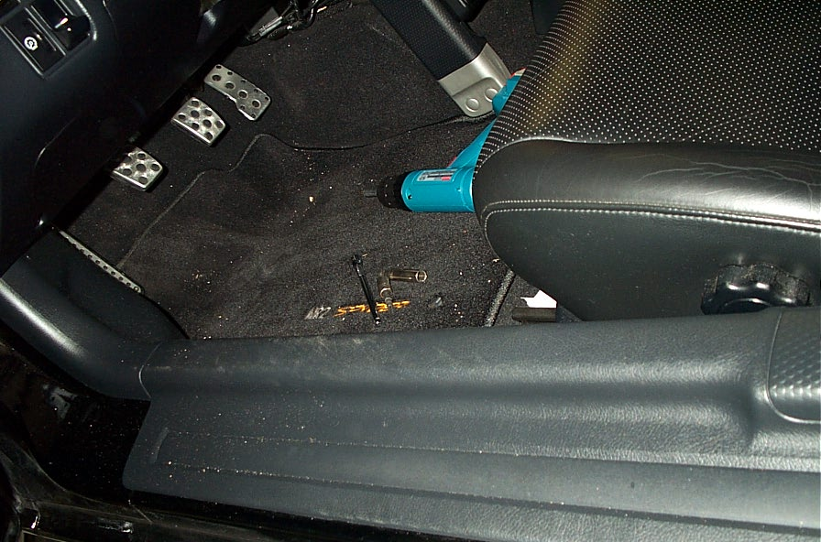
- Remove the driver’s side running board panel with a panel removal tool. This panel pulls up from the rear of the car first.

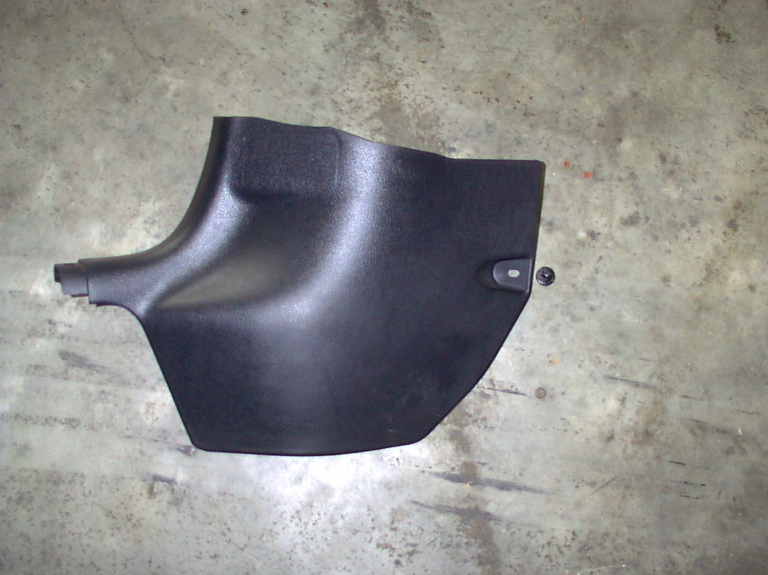
- Remove the plastic nut from the driver’s side kickpanel and remove the kickpanel.

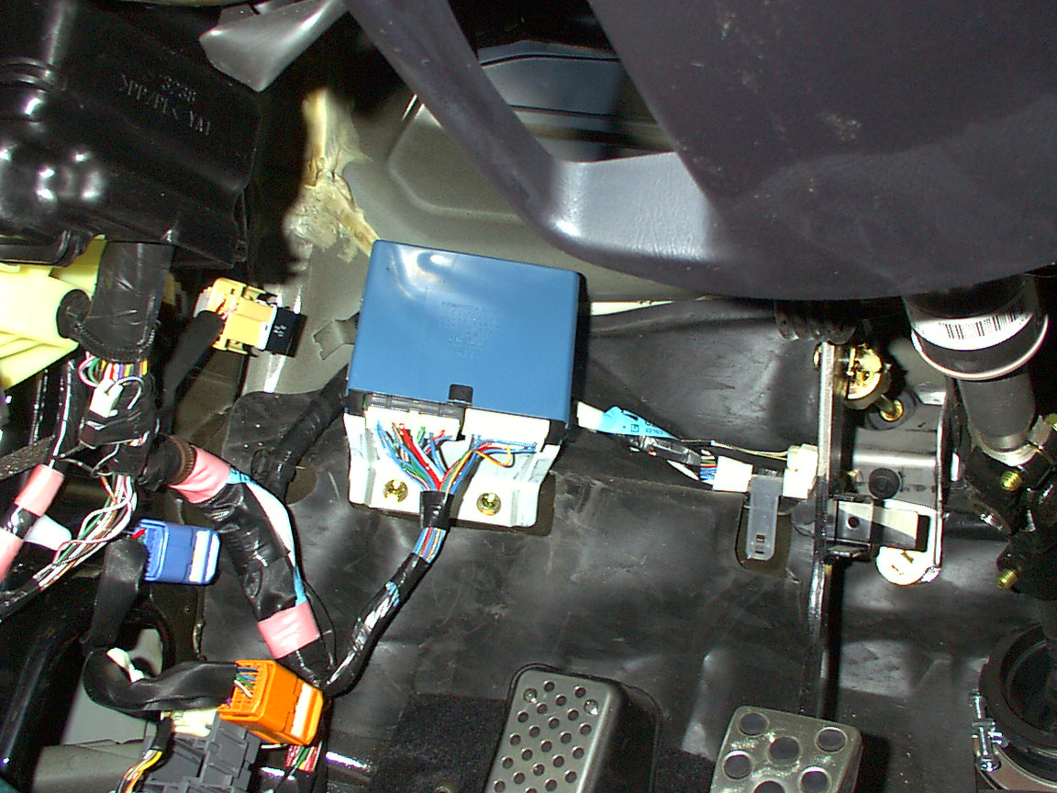
- Locate the Body Control Module (BCM).
  - This is on the firewall above the driver’s kickpanel. There are two 10mm bolts at the base of the BCM.
  - Remove the (2) 10mm Bolts and unplug the BCM. **** BE CAREFUL WITH BCM. Fragile Electronic Equipment components. MUST BE handled with great care.
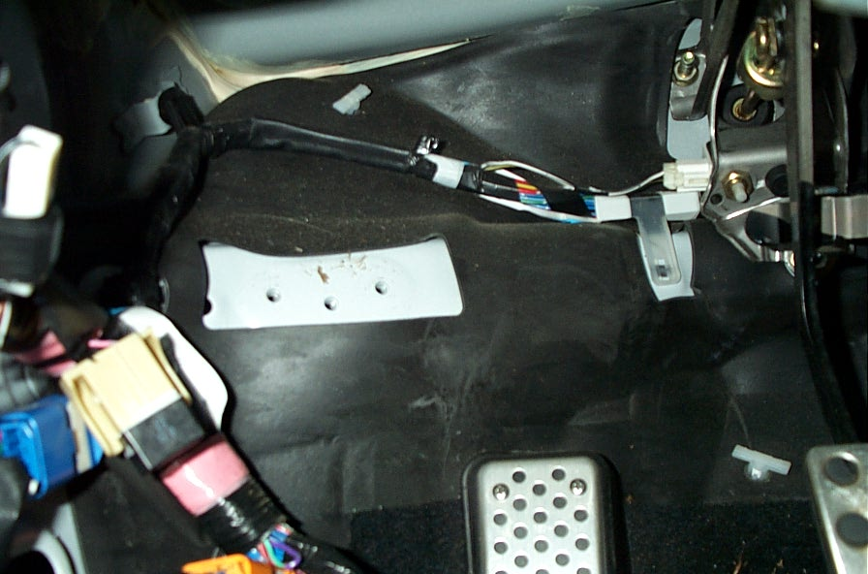

Here is what it looks like after you remove the BCM.
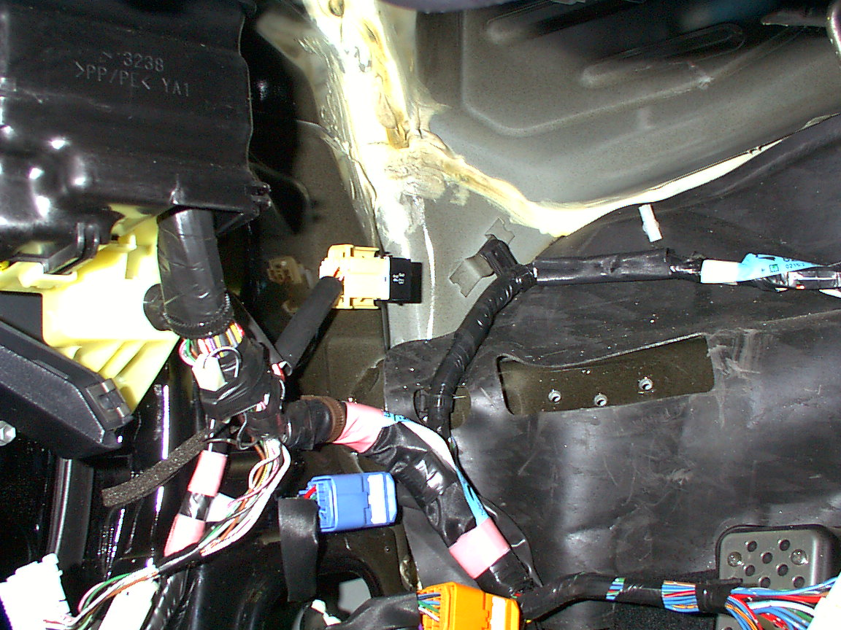
- Relocate the relay following the below procedures:
  - Look at the left sidewall above the driver’s kickpanel. You will see 1 relay pushed into the wall.
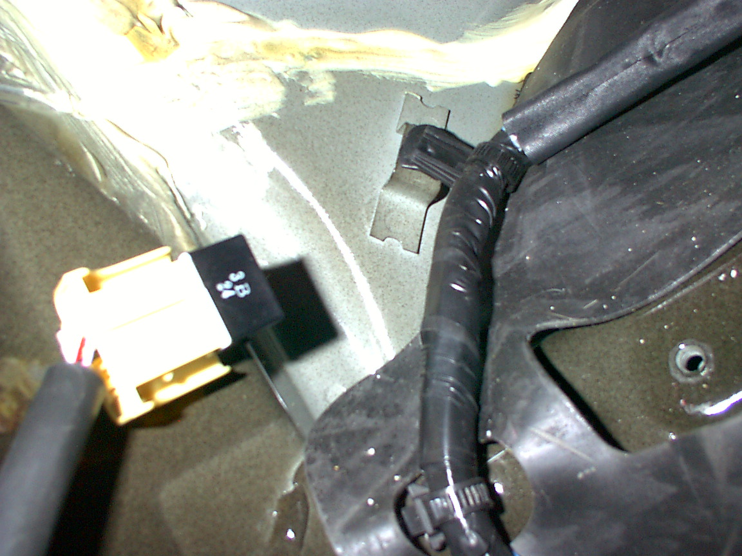
  - This relay assembly must be moved down into the kickpanel and tied to another wire harness.
.

Do Not wire tie relay until UD Sub Box is mounted firmly in the car.
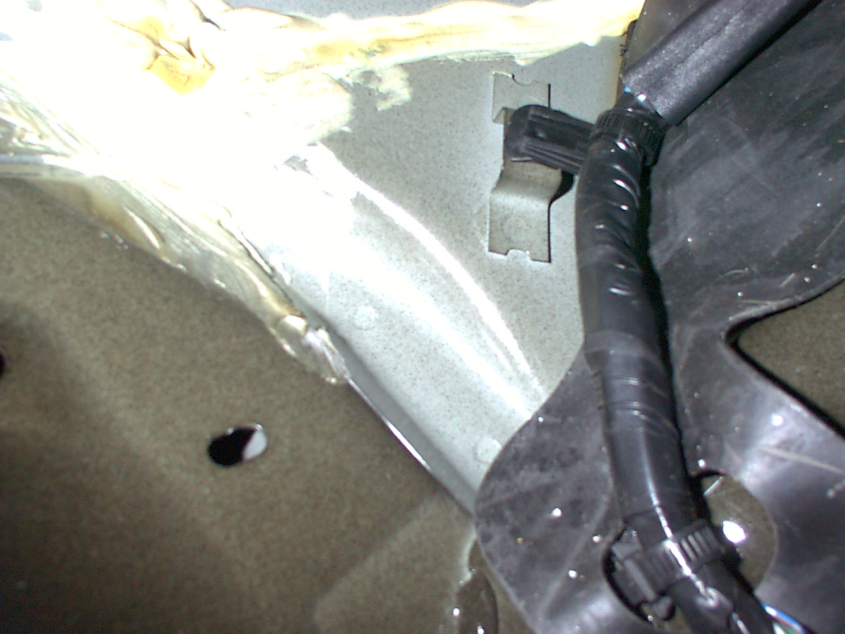
*** Use the supplied wire tie.

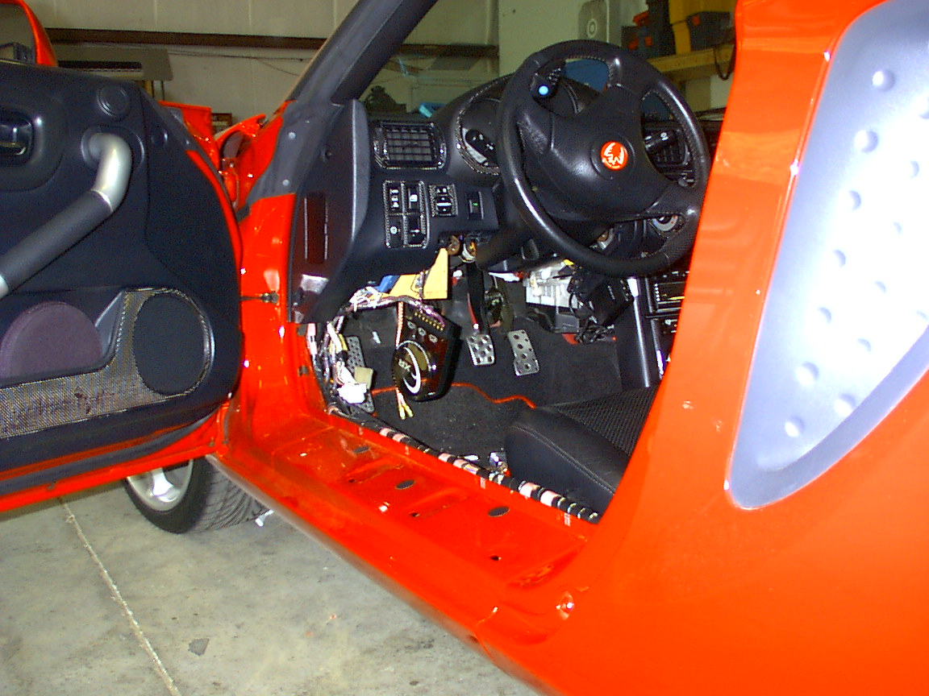
- Mount the supplied Flex Bracket using the following procedures:
  - Locate the 10mm nut that fastens the control module bracket to the round metal framing under the dash. This nut is located to
the left of steering column. The bracket goes up and toward the front of the car.
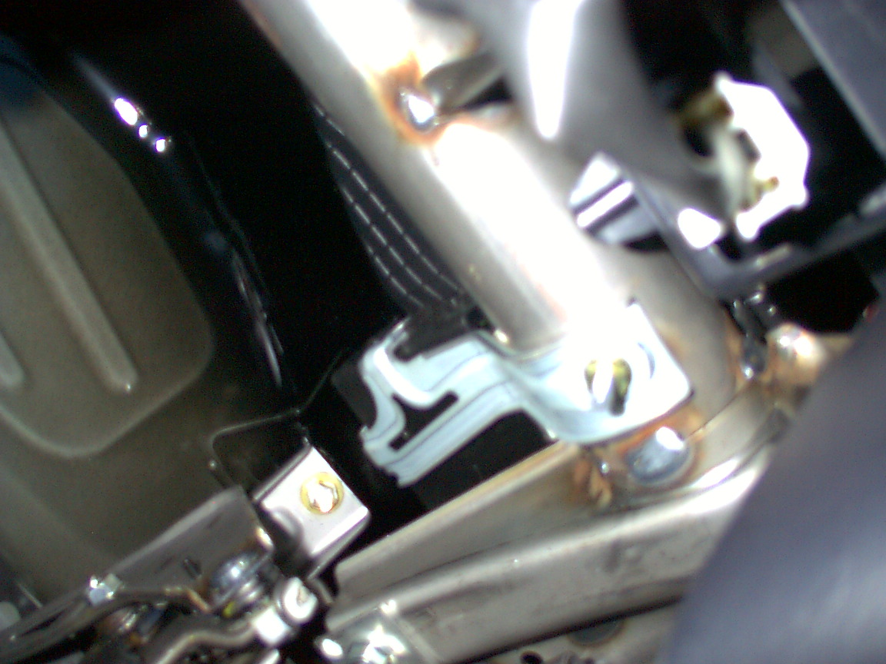
  - Remove the 10mm
nut and attach the supplied Flex bracket as shown in pictures following this procedure.

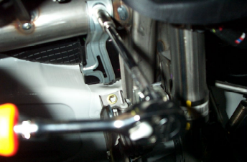Use the first hole in the bracket near the bend. Counting inward from top it will be the 2nd hole.
.

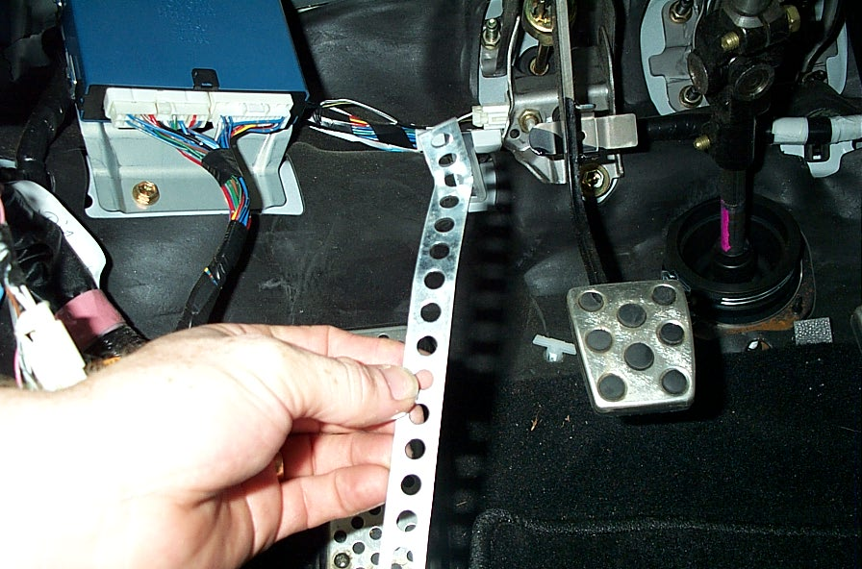
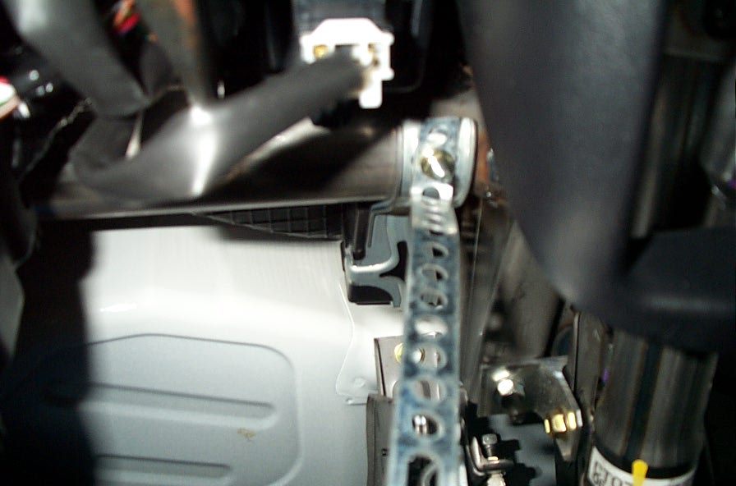

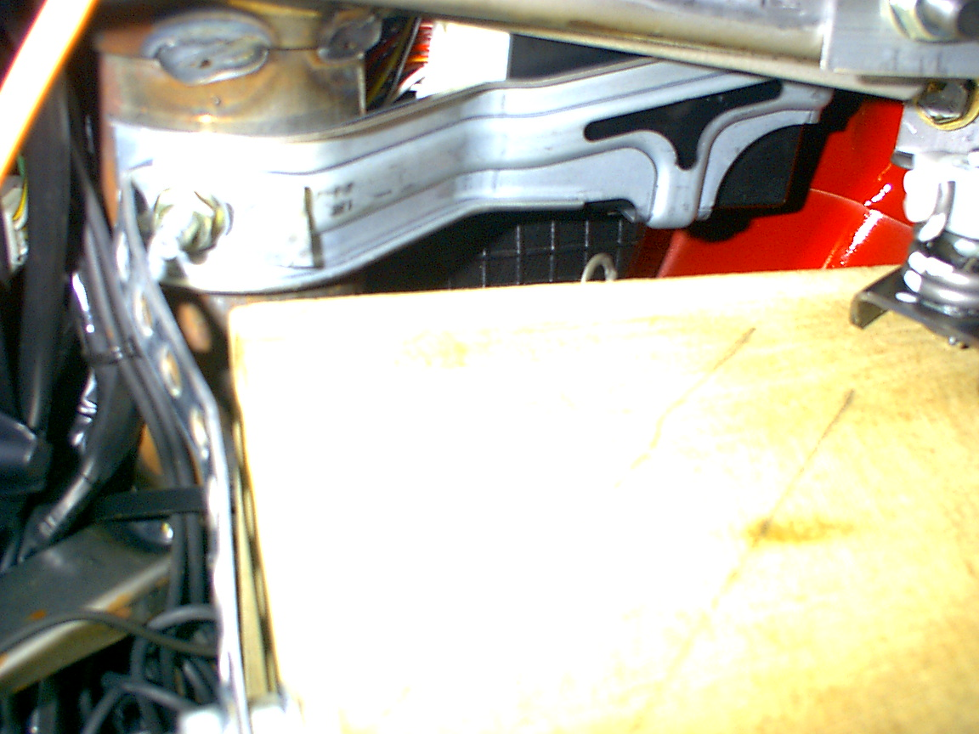
This picture shows the Flex Bracket after tightening. Notice the bracket’s position and angle. This picture was taken upward from below the steering column. Notice the bracket is square with the factory bracket where they meet, and the bracket leans toward the driver’s side.
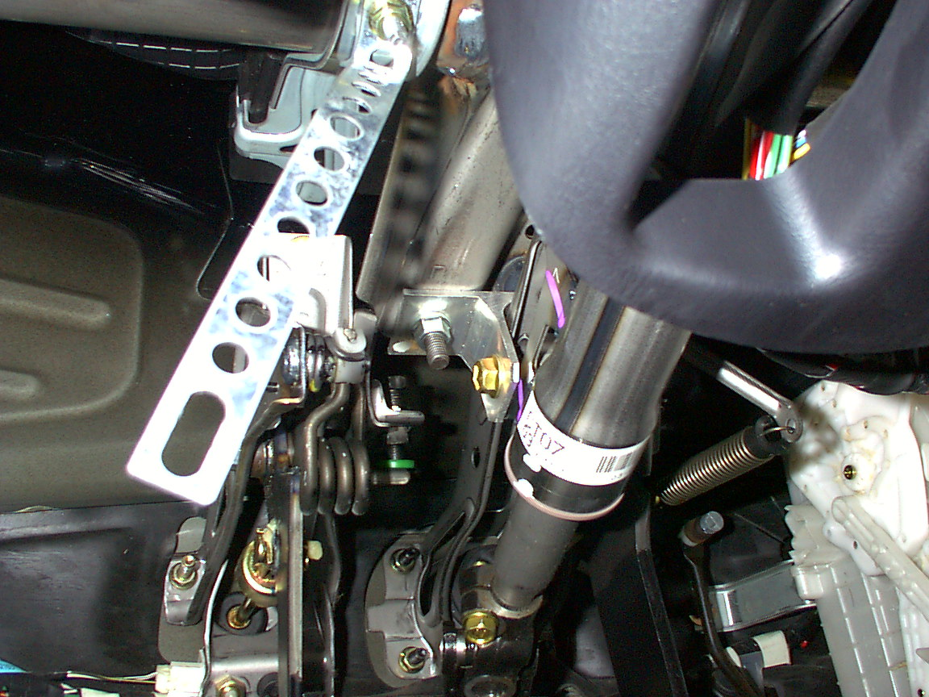
The front Flex Bracket should point down toward the driver’s side at a slight angle.



- Attach your speaker wire to the terminal cups on the UD Sub Box.

We have now reached a milestone. Take a breather and get ready to finish the last steps. We are ready to install the UD Sub Box.

The Sub is going to fire upward in your Spyder.

Here is a sample drawing of your installation.
This is how the UD Sub Box fits in the Spyder.

****You must have the speaker terminals prewired before this step. The red terminal is positive and the black terminal is negative.

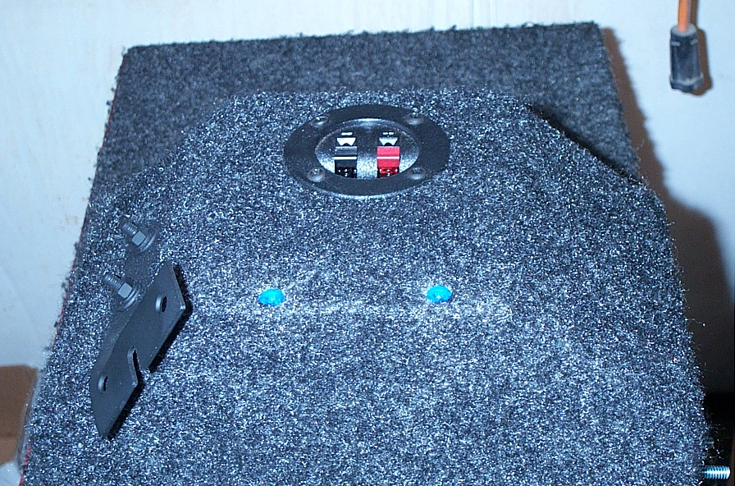
- Mount your factory BCM from step #7. The BCM mounts to the two blue dowels located below the speaker terminal cup near the bottom side of the sub enclosure.
Use 2 screws supplied.

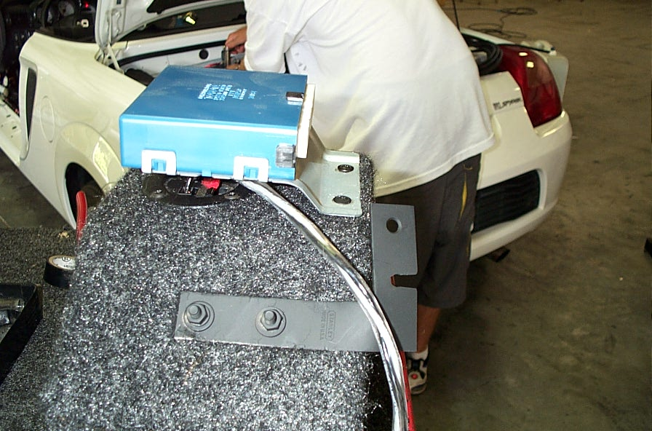
NOTE: Be careful with the wiring, as you won’t be able to easily access the terminal cup after the BCM is mounted.

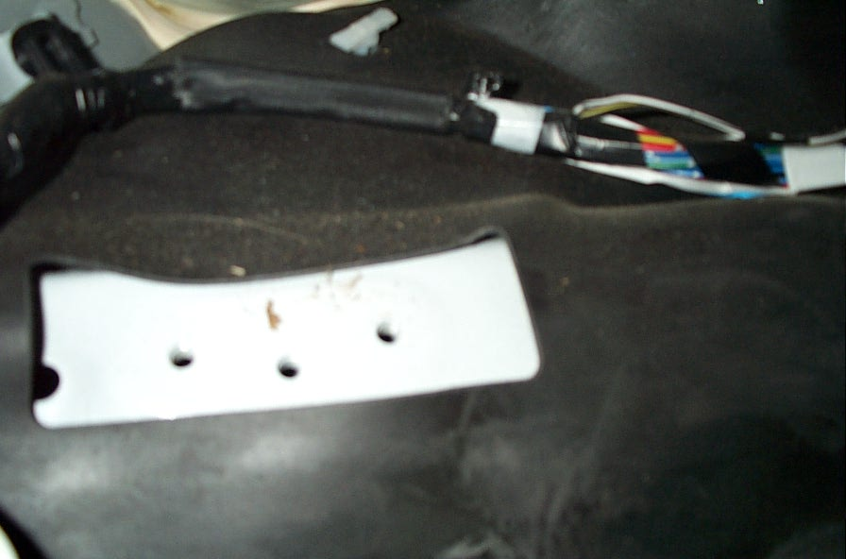
- Mount the enclosure with the Main Bracket. Note the bracket has three holes in it. ONLY two bolts will line up. DO NOT attempt to use all three mounting holes as they are
Not all used.

- Plug the factory BCM in and insert the UD Sub Box into its mounting position. We will reuse the two 10mm bolts that mounted your BCM. You need to press the clutch inward to fit UD SUB Box into the mounting position.
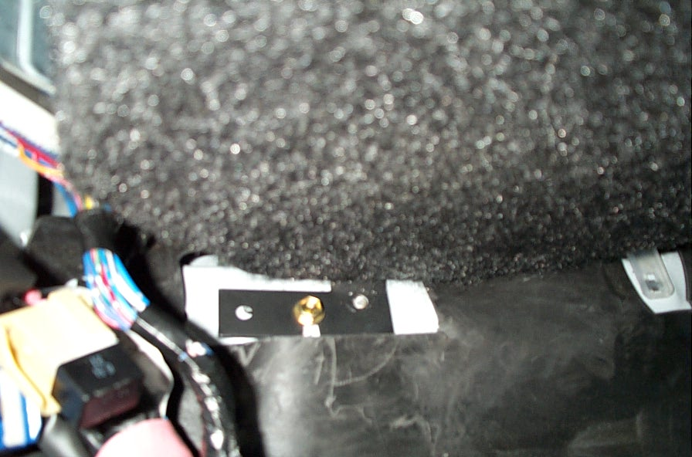
  - Insert the center bolt first and tighten slightly.
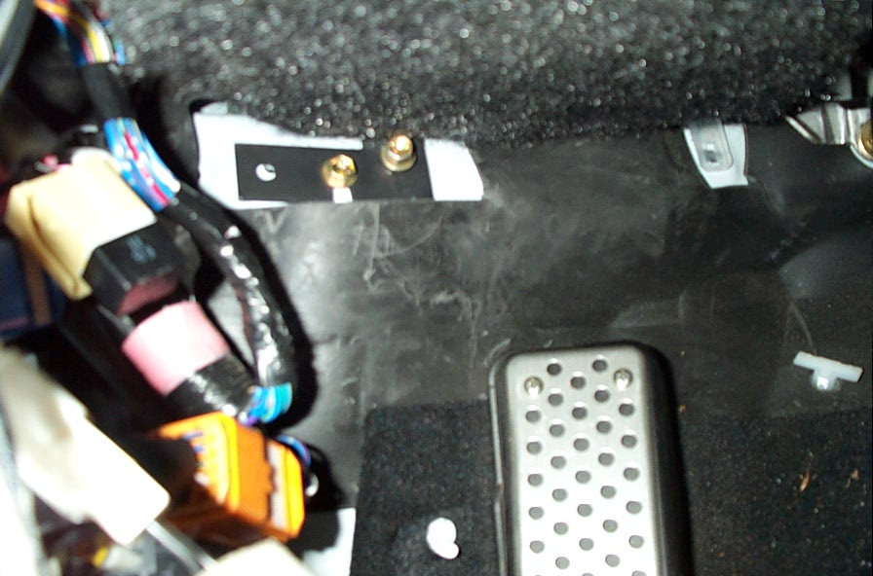
  - Insert the second bolt into the hole that is located to the right of the center bolt.
  - Once both bolts are inserted, fully tighten both bolts.

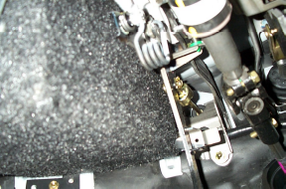*** The best tool to install the UD Sub Box is a 10mm GEAR Wrench made by Snap-On. If this tool is not available, use a standard open-end 10mm wrench.
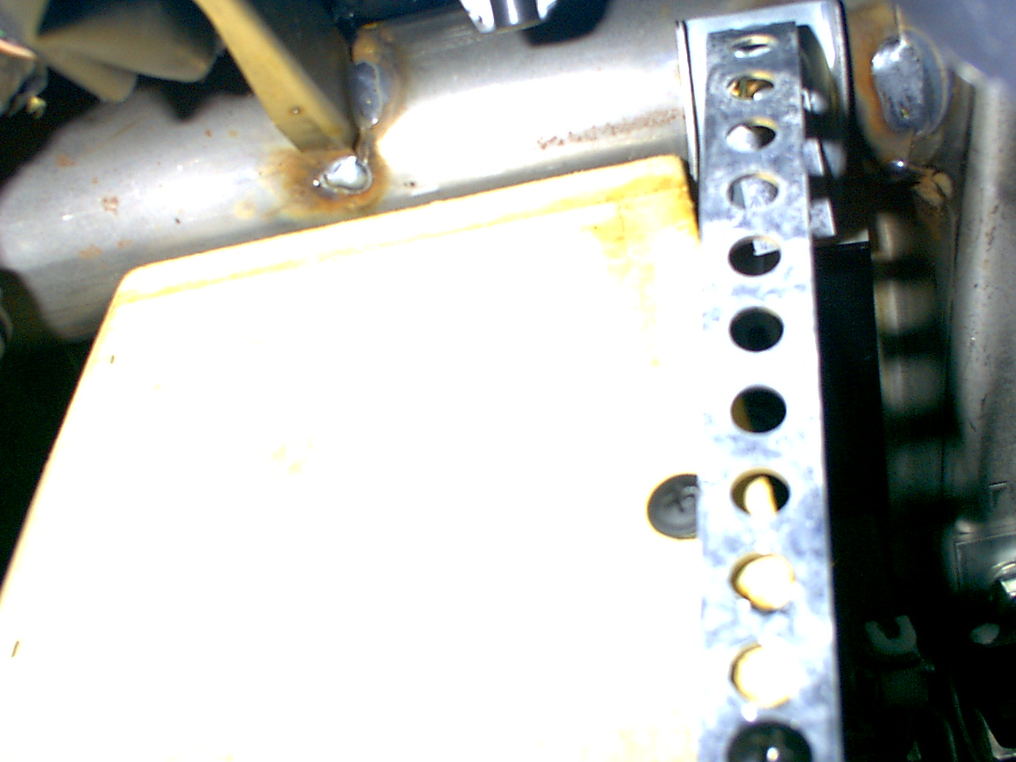

This picture gives you a good idea of how the UD Sub Box should look on the front side near the metal framing bar. Disregard the screws in the picture; they are from the developmental stages of the UD Sub project. There should be less than ¼” gap between round metal and UD Sub Box.

- 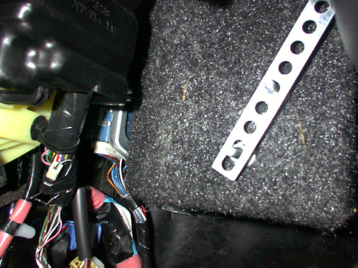Mount the Flex Bracket to the UD Sub Box.
  - There is a double bolt assembly on the front side of the UD Sub Box. Bend the Flex Bracket into place as shown.
  - In this order, place washer-lock washer-nut onto each bolt. These bolts will secure the front flex bracket to the UD Sub Box. Be sure to note the exact position of the assembly bolts on the Flex bracket. (Elongated hole #1 and hole #4 on the bottom of the Flex Bracket.) The bracket may require some flexing and bending to get it into position.

- Ensure all 4 mounting bolts are fully tightened and that your clutch has clearance (If not, you may have used the wrong mounting holes in the car).

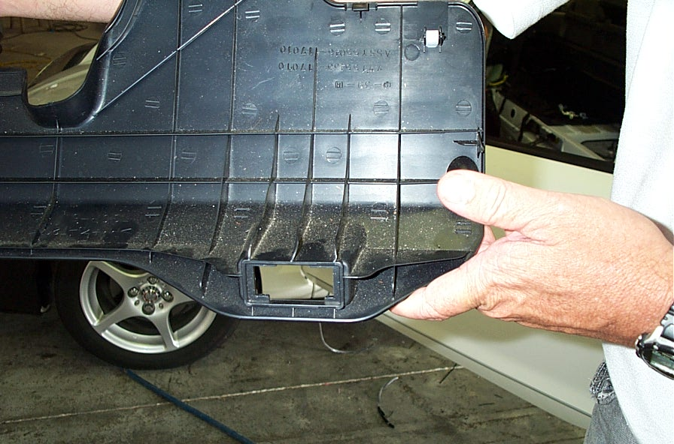
- Locate the Knee Panel. This panel has reinforcement plastic flanges everywhere on the backside. Above the diagnostic plug there are three flanges that need some minor modification.
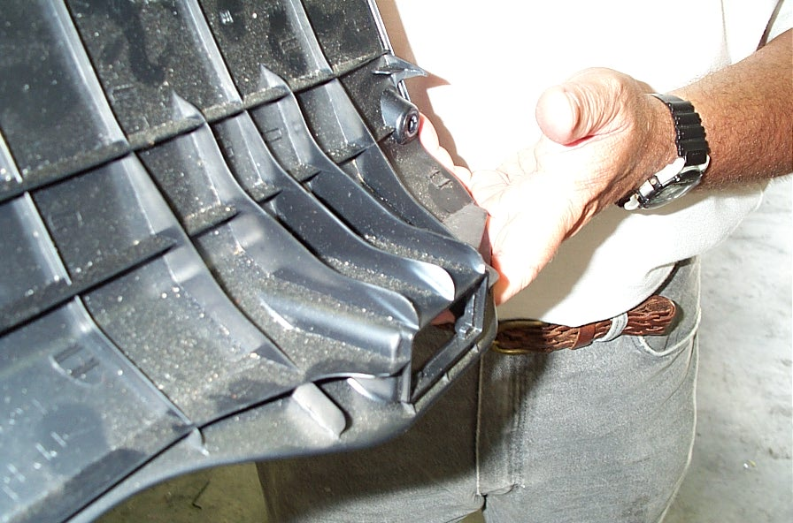
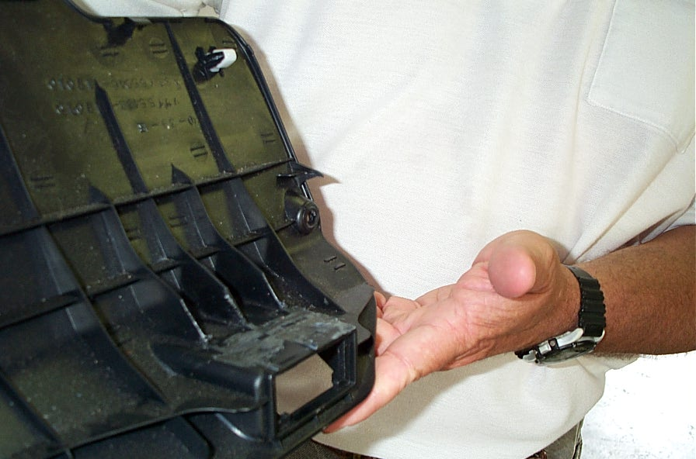

Cut plastic flanges down to panel height and cut them back approximately 2”. I chose to flange my cuts at an angle and I also used a right angle air grinder to perform this modification.

- Finish reassembling the vehicle and don’t forget to reconnect the battery.

CONGRATULATIONS!! You are finished with the install!!

